Common Performance Tunning Setting in Weblogic Domain

1.Setting the Java parameters to start the Weblogic Server

Weblogic 12c- Jdk1.8-Application(prog-jdk1.8) – New Application(jdk1.9)-not work

Weblogic14c -Jdk11(Application-Jdk11 or jdk8)- New Application(JDK12)

Analysys- Weblogic Java/Application Java (Both are same)-Working

Change the New Java version path edither JDK or JRE

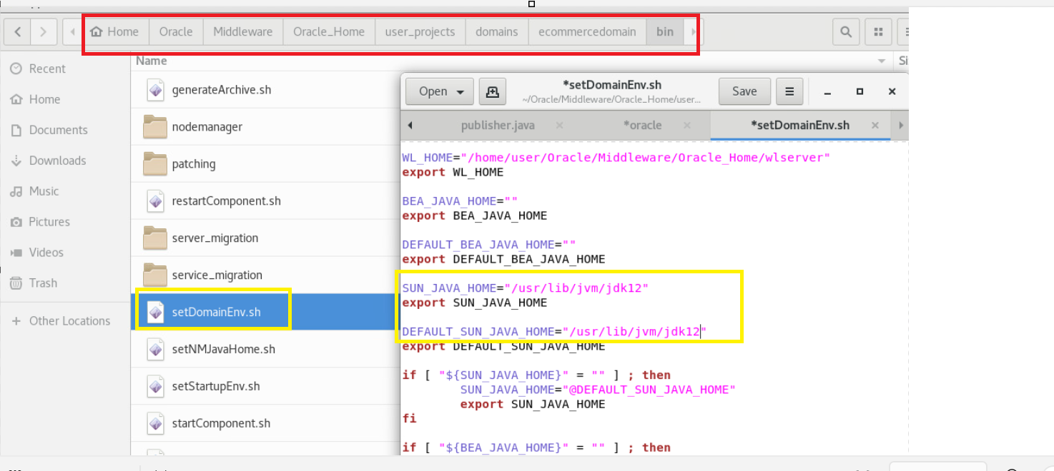

In AdminConsole--→Home >Summary of Deployments >Summary of Servers >MS2
---→ServerStart
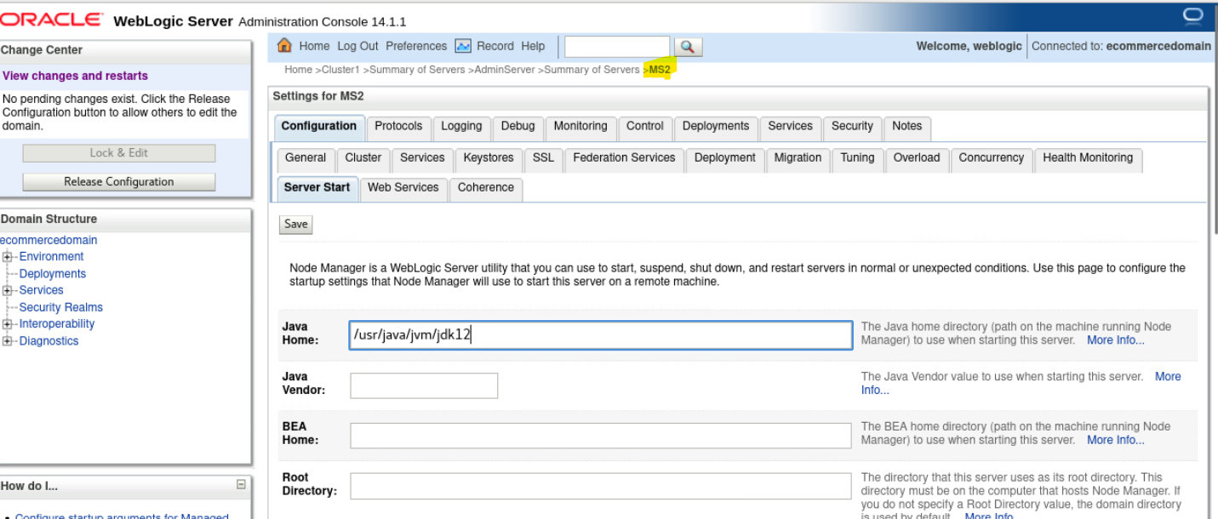

2.Memory Performance
a.try to keep the free memory equal to Used memory
Only by running the Garbage Collector in a scheduled manner
(1 ms to 2 seconds)

Example:

1 Server= 1024MB on total JVM Memory

In runtime as admin you have to maintain 512MB is occupied(used memory) out of 1024

Remaining 512MB should be free

Occupied 512MB JVM memory= 200 Req/sec 100 transaction/Minute

Free 512 MB= 500 Req/sec 200 Transaction/Minute

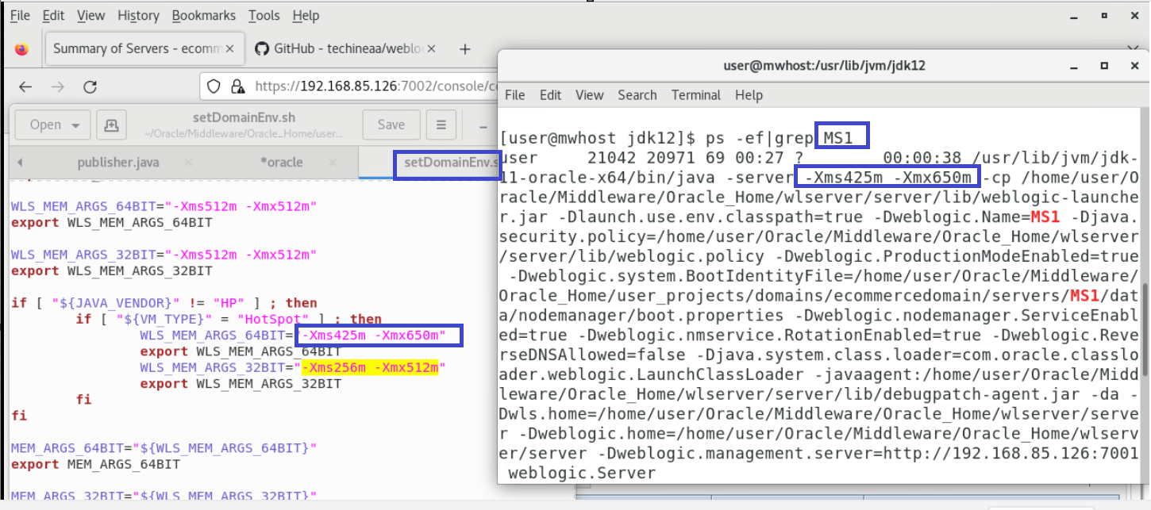

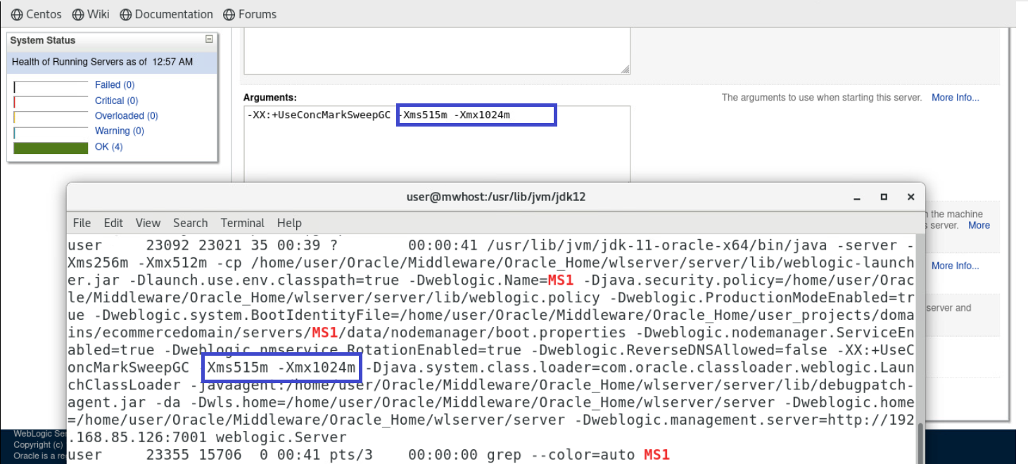

3. default Values of Weblogic Domain

JDBCConnectionpool or DataSource----max capacity DM-15 PM-15
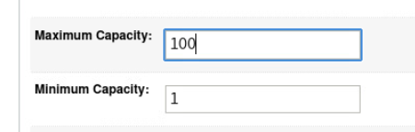

4.Equalizing JDBCConnection Pools or DataSource Min Capacity=MAx Capacity
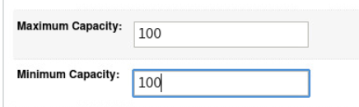

JMS Tuning

5. Try to Avoid JMS File Store in the total WEblogic Environment

6.If JMSFile Store is Used, set it to Paging Store in JMS Server for Temporary Messages

7.Try to Insist development Team to develop the total JMS Application by using

EJB(MDB)+JMS(javax.jms)=Message Application---Asynchronous or Non Durable

Avoid this------Servlet or JSP +JMS= Message Application---synchronous or Durable

8.In the JMS ConnectionFactory, to achieve distributed message load balancing set

ServerAffinity Enabled and LoadBalancing Enabled

9.According to the Applications Usage increase the Message Capacity Size

10.try to use separate Weblogic server for JMS Operations

11. Backup the Log Files and keep the log files size very less

